# Summary

## Background

Employee Relationship Management system is a Web-based App used to store and manage all employee information. It will include employee’s basic information such as job position, belonged department and contact details, aiming for convenience of information look up.

## Interview questions

Before the meeting with our clients, we prepared lists of questions:

* Who’s the target user?
* What are the main functionalities?
* What are the main modules of functionalities (you think the most important)?
* How much accessibility you wish to give to the user?
  + e.g., Are users allowed to upload multimedia resources like pdf and videos?
  + Are there any privacy requirements?
* Web-based or mobile-based application?
* What’s your ideal design style?
* Do you have any similar examples?

## Client requirement

According to the description of our client, we summaries the objectives and ideal outcomes of this project in a Who-Do-Be-Feel table and further transfer this into an motivational map.

|  |  |  |  |
| --- | --- | --- | --- |
| **WHO** | **DO** | **BE** | **FEEL** |
| Administrator | Manage users (..) | Reliable | Empowered |
| Edit employee information | Reliable | Empowered |
| Standard users (employee) | Login | Secure | Confident |
| Edit personal information (upload) | Reliable | Capable |
| Search for employees by multiple options (i.e., name, value stream…) | Flexible | Convenient& empowered |
| View personal & other’s profile | Capable | Engaged |
| Manage contacts | Flexible | Empowered |

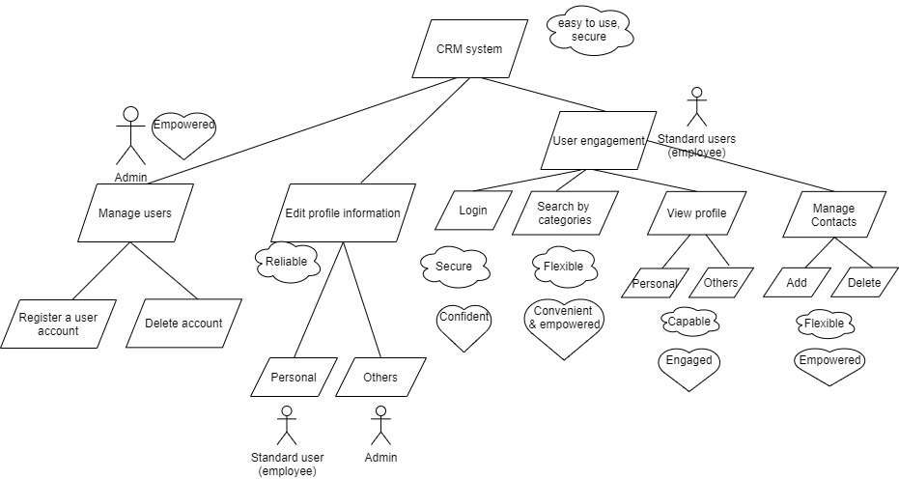

Figure Motivational Map

## User and Character

Administrator:

* Manage users (Add, Delete or Edit employee)

Standard employees:

* Maintain Personal information
* Lookup other employee’s information in the system

## Requirement priority

|  |  |  |  |  |
| --- | --- | --- | --- | --- |
| Module | As a <Role> | I want to <Do something> | So that | Priority |
| User Management | Admin | Login as admin | Access admin functionality | High |
| Register a new account | Provide to new employee | High |
| Delete an account | Deactivate left employee’s account | High |
| User engagement | Admin & standard user | Search by different options (i.e., name, value stream) | Get close results | High |
|  | Select and view result profile | View specific user profile | High |
| Profile info Management | Admin | Edit anyone’s information | Update with new info / fix errors | High |
| Standard user (employee) | Edit only personal info | Update with new info / fix errors | High |
|  | Upload different media types (i.e., images, texts) | A richer profile can be exhibited | Low |
|  | Multiple sections for types of information | Make it easier to browse | Medium |
|  |  | Change visibility of profile item (public/private) | Restrict access to private information | Low |
| Contacts Management | Standard employee | Add one employee into his contact list (as contacts) | Make it faster to find frequently connected employee | Medium |
|  | Delete | Make the system flexible | Medium |